,

Low Carbon Tourism for Emblematic Mediterranean Mountains Erasmus+ Project

Common template for the analysis of the emissions profile











Analysis of the emission profile obtained for the approach defined
Territory: Psiloritis Mountain

- First analysis

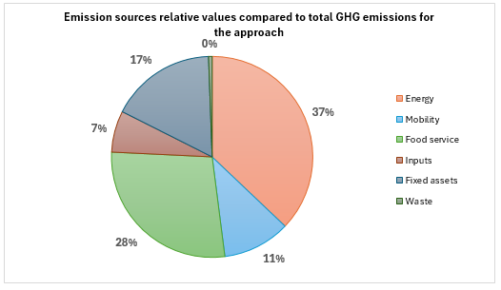
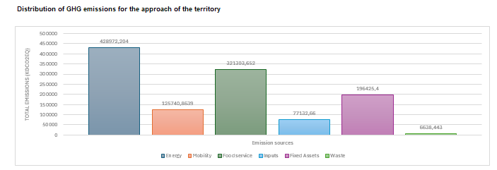
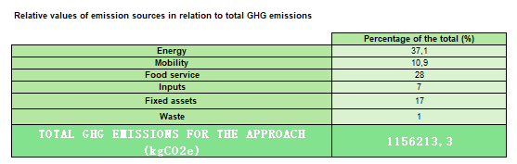

At first glance, what results do you get? Which sources of emissions have the greatest/least impact?

As can be seen from all the diagrams, the main source of emissions is energy (37,1%), followed by food service (28%) and fixed assets (17%). On the other hand, waste and inputs seem to have a small impact on the overall result (1% and 7% respectively). The relatively small impact of mobility is interesting, but this can be explained by the fact that only the calculation of movements from the large urban centers of Crete to the region was chosen and not the emissions that may be associated with the movement of visitors to the island from their place of residence.

- Linking the result with the first tabs of the tool: definition of the approach

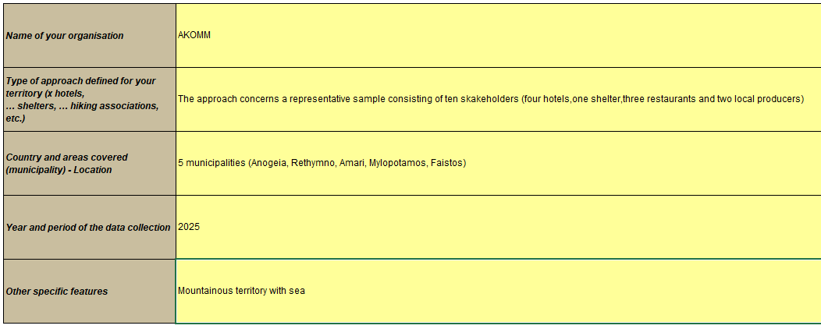
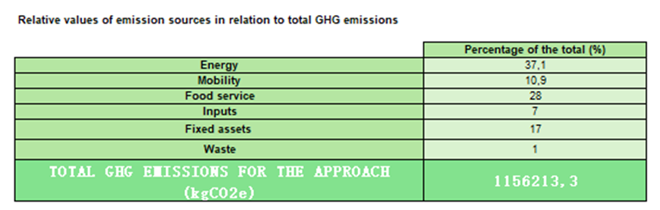

What do these results show? Is your result relevant compared to the initial approach defined for your territory? Do you identify some missing data to be aligned with the approach? If yes, what could you do to get the missing data?

The area covered is particularly large as it extends to five different municipalities in an area that presents intense tourist activity in the summer months, but also remarkable activity in the winter period. This specific sample of stakeholders was selected as it was considered to be sufficiently representative and would lead to initially reliable and close to reality results. The data collection was complete, however, the following assumptions were made in order to simplify the process: the impact of activities and the mobility of employees in the establishments were not taken into account as it was considered that the vast majority of them live close to their workplaces

- Linking the result with the first tabs of the tool: assumptions and extrapolations
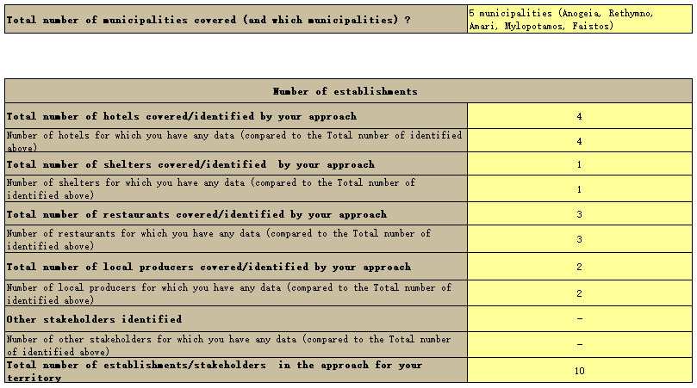

Do you think the number of hotels, shelters, etc. is enough to have good insights of the territory? Do you have any other data that you could add to complete the result (data on tourism, population of the territory, etc.)

The number of stakeholders selected is representative of the four categories included in the regional energy footprint calculation tool. The aim of this tool is not to capture the total amount of emissions produced by the region over a given period of time – this would require multiple resources in time and money. This approach allows an assessment of the distribution of gas emission sources into six basic categories for the purpose of analysis and development of targeted actions. So, the sample is considered representative with the possibility of including more stakeholders in it in the future for greater accuracy and consistency.

- Understanding the importance of defining the approach and the temporal perimeter

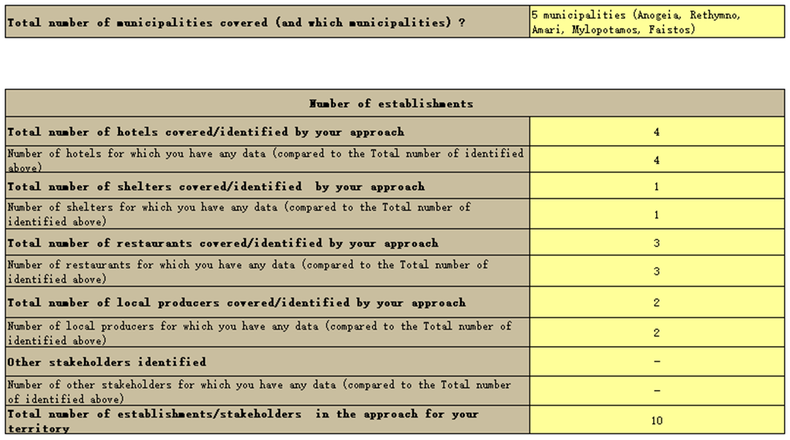

Why are these values important regarding the results? What assumptions have you made based on these values? How did you use them for extrapolations?

The final phase of data collection was carried out during 2025 in collaboration with the stakeholders participating in the sample. A significant effort was made to ensure that the data covered an entire calendar year in order to draw the most reliable conclusion possible. Given that, as mentioned above, the sample is small but representative in relation to the total number of stakeholders operating in the region, special emphasis was placed on the accuracy of their responses. Assumptions were used based on the long-term experience of managers in relation to dynamic data such as the number of visitors per month or meals consumed. The time period chosen for each establishment type and each emission source plays a very important role and varies depending on the case. So, for example, the operating period of restaurants is one year and that of hotels is six months, but with regard to electricity consumption, data was collected based on consumption for the entire year, as there is consumption even during the period when they are not receiving visitors.

- Analysing the final circular diagram and the final tab in the results

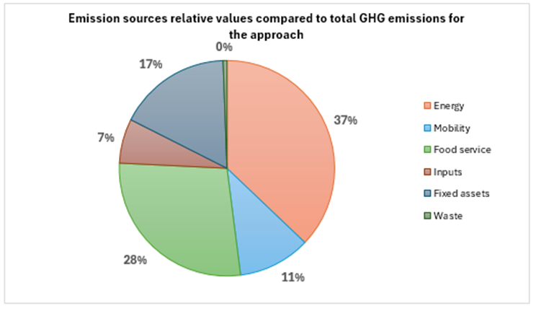

Taking into account assumptions/extrapolations, what can be said about the result obtained? Is it reliable, do you have a lot of uncertainties from the assumptions/extrapolations made?

The most important emissions source as reflected in both diagrams is energy with 37% followed by food service with 28%. As mentioned previously, the data for energy is not based on any assumption or correlation, they are real and concern the entire year 2025. The result for food service has been obtained with assumptions and deductions as it is a multifactorial sector for which it is difficult to obtain accurate data. For example, the number of meals consumed has been derived by extrapolating an average daily consumption to 260 operating days per year for restaurants and 180 for hotels. The collection of more precise data from establishments might lead to a differentiation of the results. Accordingly, the contribution of mobility could change if a more reliable method could be found to calculate the average number of people visiting the area daily and also if knowing from which starting point.

- Analysing circular diagrams for every emission source:
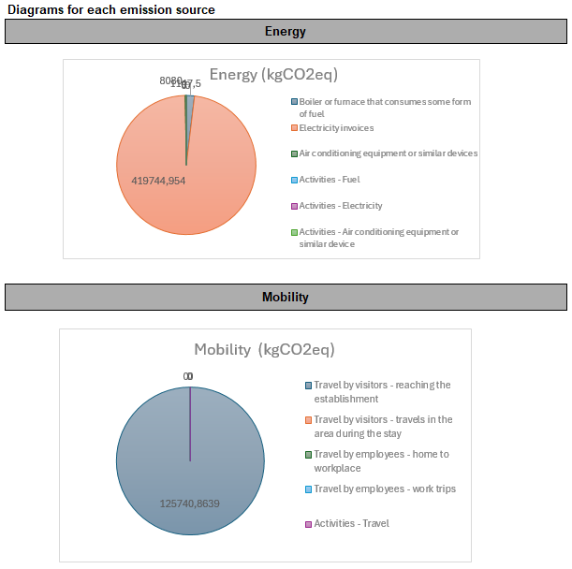
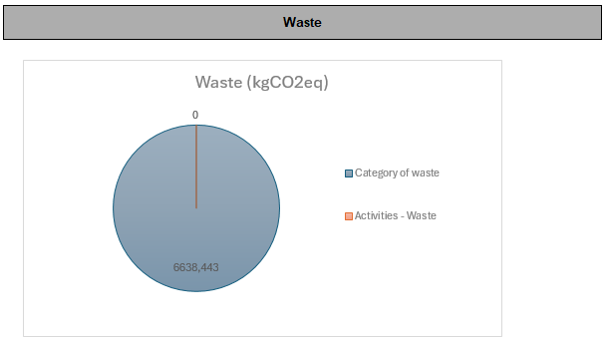

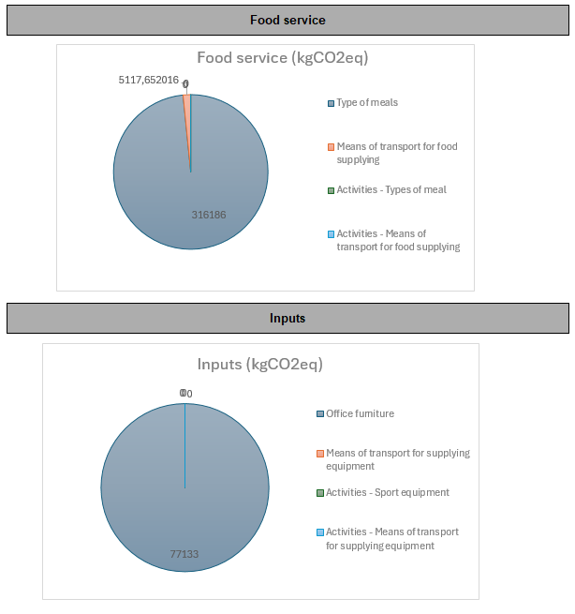
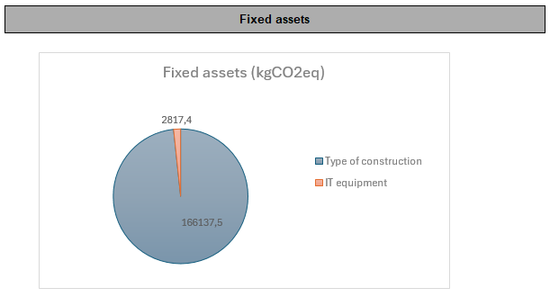
Which circular diagram do you find easiest to analyse? What could you do/what questions could you ask yourself to complete the data and obtain a more accurate diagram?

First of all, we recall one of the basic assumptions mentioned at the beginning of the analysis of the result, namely that emissions associated with activities were not taken into account as it was considered that their impact would be small and disproportionate to the effort that would have to be made to concentrate the corresponding data. Also, the movements of employees were not included as it was considered that the vast majority of them live close to their workplaces. These two elements can be considered in future actions to update and use the tool. Analyzing the diagrams for each emission source, we observe that for energy, the effect of electricity is catalytic, as for several years it has been the main source for cooling/heating indoor spaces in the country. Taking this into account, it is vital to carry out energy upgrading actions in buildings and green transition, as this will drastically reduce the environmental footprint of the entire area. Regarding mobility, visitor movements to the area are the largest part anyway, but it would be useful to include in the future also the movements made by visitors within the boundaries of the area. For food service, the establishments' supplies from their three main suppliers have also been included. For inputs, their procurement was not included as it was considered that it did not take place within the reference year. For fixed assets, the total of those requested was included in the diagram and it was expected that the largest part would concern the type of construction of the buildings, where measures should be taken in the future to reduce the impact they have. Finally, regarding waste, it would be useful to try to determine the quantities of waste that visitors produce during their movement in the area and not only during their stay in the establishments.

- Final result and comparative values

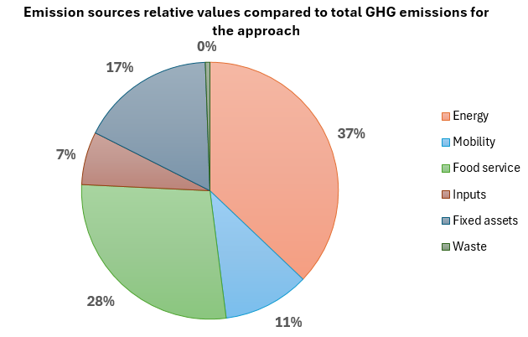
Psiloritis mountain result (for a year): approximately 1156 tCO2eq

To have a better understanding of the results obtained, adding some equivalence in terms of values can be interesting: https://impactco2.fr/outils/comparateur#simulateur.

The result for the approach chosen for the region is approximately 1156 tCO2eq which corresponds to 133 laps of the Earth by car or the emissions from 14,442 smartphones. However, it should be taken into consideration that the sample includes only ten stakeholders, so the final possible result for the entire region will be many times higher.

